Step 1: In the welcome window, click “Configure”.

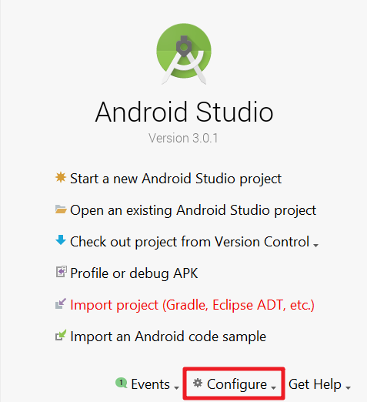

Step 2: In the dropdown, select “Check for Update”.

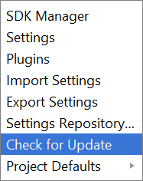

Step 3: In the pop-up, click “Update and Restart”.

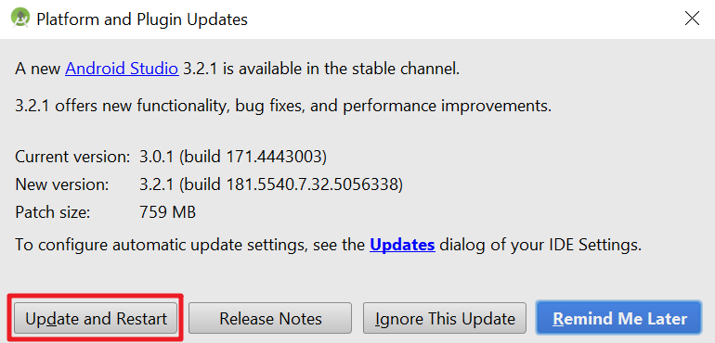

Step 4: In the next window,

* If you would like to import your previous settings, choose the first option and click OK.
* Else, choose the “Do not import settings” and click OK.

